Earliest Deadline First (EDF) Scheduling

// Earliest Deadline First (EDF) Scheduling

#include <stdio.h>
#define MAX 10

typedef struct {
int id, at, bt, deadline, remain;
int done;
} edf;

int main() {
edf p[MAX];
int n;

printf("Enter number of process: ");
scanf("%d", &n);

for (int i = 0; i < n; i++) {
p[i].id = i + 1;

printf("AT %d: ", i + 1);
scanf("%d", &p[i].at);

printf("BT %d: ", i + 1);
scanf("%d", &p[i].bt);

printf("Deadline: ");
scanf("%d", &p[i].deadline);

p[i].remain = p[i].bt;
p[i].done = 0;
}

float U = 0;
for (int i = 0; i < n; i++) {
U += (float)p[i].bt / p[i].deadline;
}

if (U > 1.0)
printf("Scheduling not feasible (Deadline may be missed)\n");
else
printf("Scheduling feasible\n");

int t = 0, done = 0;

printf("\nExecution Order:\n");

while (done < n) {
int idx = -1;
int min_deadline = 9999;

for (int i = 0; i < n; i++) {
if (p[i].at <= t && p[i].done == 0) {
if (p[i].deadline < min_deadline) {
min_deadline = p[i].deadline;
idx = i;
}
}
}

if (idx == -1) {
printf("Idle at time %d\n", t);
t++;
continue;
}

printf("Time %d -> P%d\n", t, p[idx].id);

p[idx].remain--;

if (p[idx].remain == 0) {
p[idx].done = 1;
done++;
}

t++;
}

return 0;
}

Output :-
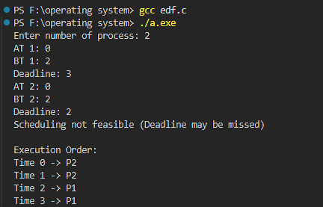

Proportional Sharing Scheduling
#include <stdio.h>
#define MAX 10
#define TQ 10

typedef struct {
int id, bt, wt, remain, done;
} process;

int main() {
process p[MAX];
int n;

printf("Enter no. of process: ");
scanf("%d", &n);

int total_wt = 0, total_bt = 0;

for (int i = 0; i < n; i++) {
p[i].id = i + 1;

printf("Process %d BT and weight: ", i + 1);
scanf("%d %d", &p[i].bt, &p[i].wt);

p[i].remain = p[i].bt;
p[i].done = 0;

total_wt += p[i].wt;
total_bt += p[i].bt;
}

int done = 0;

printf("Execution Order:\n");

while (done < n) {
for (int i = 0; i < n; i++) {
if (p[i].done == 0) {

float slice = ((float)p[i].wt / total_wt) * TQ;
int time_slice = (int)slice;

if (time_slice <= 0)
time_slice = 1;

if (time_slice > p[i].remain)
time_slice = p[i].remain;

printf("P%d runs for %d units\n", p[i].id, time_slice);

p[i].remain -= time_slice;

if (p[i].remain <= 0) {
p[i].done = 1;
done++;
total_wt -= p[i].wt;
}
}
}
}

return 0;
}

Output:-
